**Vygotsky's Theory of Sociocultural Cognitive Development**

Lev Vygotsky (1896-1934) was a Russian psychologist and teacher who developed a theory about how our social interactions influence our cognitive development. This is known as Lev Vygotsky's Sociocultural Theory of Cognitive Development.

**What is Vygotsky's Theory?**

Vygotsky's social development theory asserts that a child's cognitive development and learning ability can be guided and mediated by their social interactions. His theory (also called Vygotsky's Sociocultural theory) states that learning is a crucially social process as opposed to an independent journey of discovery. He expands on this by stating that a child's learning benefitted greatly from being guided by a more knowledgeable community member - such as a parent or teacher.

Vygotsky's sociocultural theory also suggested that children internalise and learn from the beliefs and attitudes that they witness around them. He believed that culture played an important role in shaping cognitive development and therefore that this development varied across cultures. Vygotsky also stressed the importance of language as the root of all learning.

Here are some of the concepts of Vygotsky’s theory:

**Vygotsky's Concept of More Knowledgable Other (MKO)**

Vygotsky's theory emphasises guiding children's learning through their interaction with a more knowledgeable other (MKO). The more knowledgeable other could be anyone with a greater understanding of the task or concept that the child is trying to complete or learn. Most often, this would be a parent, caregiver or teacher, but it could also be a peer or mentor.

This theory is not limited to academic or educational learning, it can also be applied to recreational learning such as playing games or using technology. In these circumstances, a peer or older child is more likely to be the more knowledgeable other.

The MKO could also be an electronic tutor, in cases where a program is set up to guide learning using voice prompts or videos. Vygotsky's theory places importance on guiding children's learning through their interaction with a more knowledgeable other (MKO). The more knowledgeable other could be anyone with a greater understanding of the task or concept that the child is trying to complete or learn. Most often, this would be a parent, caregiver or teacher, but it could also be a peer or mentor.

**Vygotsky’s Zone of Proximal Development (ZPD)**

The concept of the zone of proximal development, also known as the zone of potential development, is used to explain a child's potential for cognitive development and ability when they are guided through a task, rather than asked to do it in isolation.

If a child is presented with a task that is slightly above their ability level, the zone of proximal development (ZPD) refers to their ability to do it with the assistance of a more knowledgeable person. This theory explains why some skills present themselves in a more social context when the child is unable to display them by themselves.

The zone of proximal development can be described as the distance between the actual developmental level when assessed independently and the level of potential development when assessed in collaboration with peers or mentors or under the guidance of a teacher.

**Zone of Proximal Development Stages**

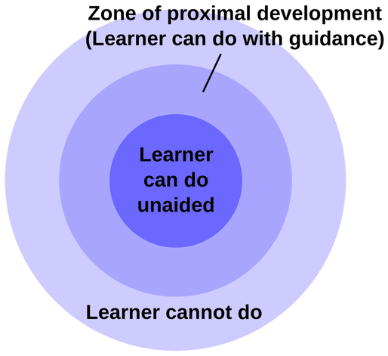

The ZPD can be broken down into three distinct stages in terms of a learner's skillset. In order to improve the ability of the learner the more knowledgeable person must understand what stage they are in.

Tasks a learner can accomplish without assistance(unaided)

This refers to tasks that the learner can perform independently. If the learner has reached this stage, the teacher or mentor will need to increase the level of difficulty of the task in order to facilitate further learning.

Tasks a learner can accomplish with assistance(guidance)

This is referred to as their zone of proximal development. In this stage, the learner needs the guidance of a more knowledgeable other to help them complete the task.

Tasks a learner cannot accomplish with assistance( cannot do)

This refers to tasks that the learner cannot do, even with the guidance of a more knowledgeable person. If the learner's ability falls within this range, the level of difficulty may need to be decreased to accommodate their skillset.

**Vygotsky and Instructional Scaffolding**

According to L.S. Vygotsky theory of development, when a learner is in their **ZPD**, an expert will provide appropriate assistance to the learner to help him accomplish a new skill or task. According to scaffolding theory, resources, tools, instructions, and activities, that are used to support the learning process are referred to as **scaffolding**.

Scaffolding refers to the structure provided by other learners while learning a skill. When someone learns a new skill, they usually follow a series of steps to master it. These steps are called "scaffolds," and they provide a foundation upon which the learner builds his or her skills.

When teaching students, teachers typically create scaffolds to guide them through each lesson. Scaffolds help students understand concepts and remember details, and they also allow teachers to focus on specific areas of instruction rather than having to cover every single topic.

‍

The benefits of scaffolding include:

* Motivating the learner by helping them through aspects of a task that they have trouble with
* Minimising frustration for the learner
* Providing a faster learning experience

**Social Influences and Cognitive Development**

Vygotsky believed that learning was an active process rather than a natural or passive one. He said that children were engaged in their own learning and discovery but that their development happened in the context of social interaction, as opposed to independently or in isolation.

Vygotsky also highlighted the importance of learning that was guided by an educator or teacher. Techniques used by the teacher to engage the child, such as performing the task themselves as an example or providing verbal instruction was referred to as cooperative or collaborative dialogue by Vygotsky theory.

The process of learning would occur when the child understood the information, absorbed it and then used it to guide their own performance.

This technique is also very common in sport, in which a coach or more capable peer will often demonstrate the skill before asking the student to do it themselves. For example, if a soccer teacher was teaching students how to dribble a ball through a set of cones, they may perform this skill first themselves in order to set an example for the students.

**Vygotsky's Theory and Language and thought development**

Vygotsky's sociocultural theory of languages and thought development posits that social interaction plays a crucial role in intellectual development. In Vygotsky's view, mental functions are not innate, but instead are shaped and influenced by social and cultural contexts. The role of language is especially important, as it serves as a tool for thought and communication.

According to Vygotsky, language is not simply a means of expressing existing thoughts, but is necessary for the formation of cognitive processes. Vygotsky argues that language and thought are inextricably linked, with each influencing and shaping the other.

Vygotsky's theory emphasizes that intellectual development is a social process that occurs through interaction with others. Through this interaction, individuals engage in external speech, which enables them to organize their thoughts and regulate their behavior.

‍Vygotsky's theory says that social interactions help children develop their ability to use language. According to Vygotsky, there are three stages/forms of language in the development process:

* Social speech - communication between children and others (usually from the age of 2)
* Private speech - private speech that is directed to the self but has not yet been internalised (usually from the age of 3)
* Silent inner speech - a child's internal monologue (usually from the age of 7)